Name: ________________________________________ Date: ____________ Period: _____________ ASSIGN
Periodic Table Practice
Part 1: Scavenger Hunt: Use your periodic table to answer the following questions.
- The element located in Period 4, Family 8 is ___________________________.
- The element located in Period 2, Group 15 is ___________________________.
- The element located in Period 7, Family 2 is ____________________________.
- The element located in Period 6, Family 1 is ____________________________.
- The element located in Period 1, Group 1 is ____________________________.
- The element located in Period 5, Family 11 is ___________________________.
- The element located in Period 3, Group 18 is ____________________________.
- The element located in Period 2, Family 18 is ____________________________.
- The element located in Period 5, Group 4 is ______________________________.
- All the elements in Group 1 belong to the _______________________________ family.
- All the elements in Group 2 belong to the ___________________________________ family.
- All of the elements in Group 17 belong to the _______________________________ family.
- All the elements in Group 18 belong to the _________________________________ family.
- The elements located between Groups 3 and 12 are called the ________________________.
- Elements that have properties of both metals and nonmetals are called ________________.
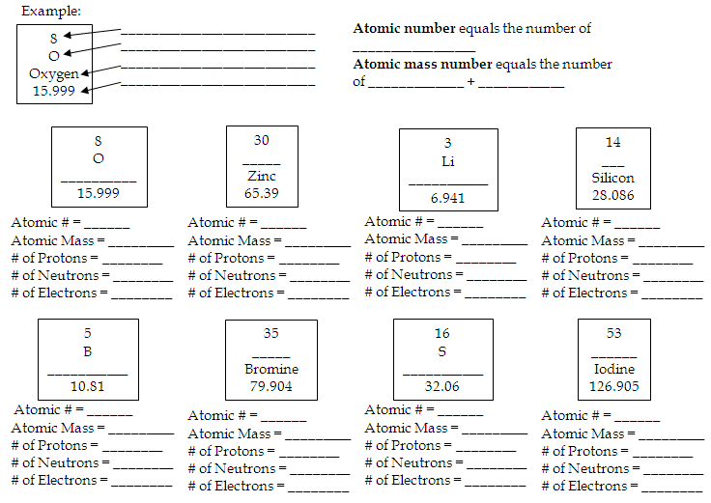
Part 2: Atomic Math Challenge: Use the periodic table to fill in the blanks below.
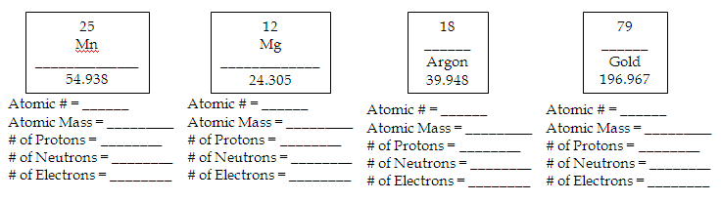
Part 3: Element Names and Symbols
Directions: Give the name, # of protons, and group # for each of the element symbols below.
Symbol | Element Name | # Protons | Group #
Ni
C
S
Ca
N
Pb
P
B
Cl
Au
Si
He
Na
K
Mg

Directions: Give the symbol, atomic mass, and period number for each of the named elements below.
Element | Symbol | Atomic Mass | Period #
Lithium
Silver
Iron
Boron
Neon
Sodium
Carbon
Oxygen
Hydrogen
Chlorine
Cesium
Magnesium

