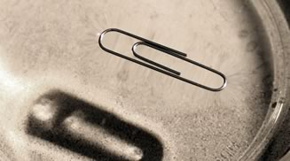
Can you make a paperclip float? Try your luck and remember that in Science, you have to try several times before you find success! Record yourself making the paperclip float and also with an explanation stating why it is able to float. You can use your cell phone or any other recording device. You can email the video to bselig@wcpss.net or show Mrs. Selig in class. If you do not have access to a recording device, you can show Mrs. Selig between 7:45-8:15 or during lunch. Have fun!

